Physics Stage 3: Exploring Physics Set 10

- a. Reflection:
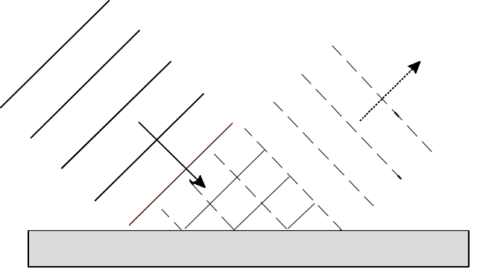

b. Refraction of sound in air

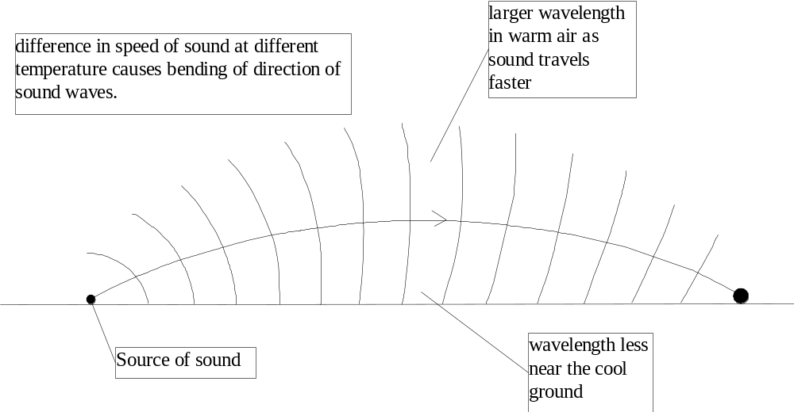
Refraction of light entering water
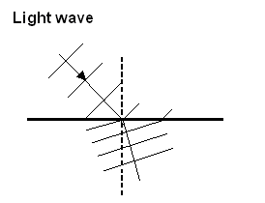

- Diffraction

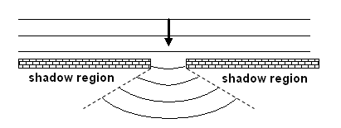

2. Copy the diagrams and complete the paths of the wavefronts as they are reflected.

a.

b.
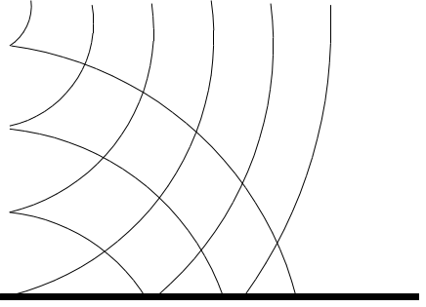

3. When a sound wave meets your ear, your ear may absorb, transmit or reflect some of the wave’s energy.
a. What happens to the wavelength of the reflected wave?

unchanged

b. What happens to the frequency of the transmitted wave?

unchanged

4. Sound researchers have noticed the way completely blind people can walk down busy streets without bumping into things. When researchers block such a blind person’s ears, the blind person tends to bump into more objects. Explain why this happens.

Some researchers believe that they navigate by sound, avoiding collisions by instinctively listening for subtle changes in footstep sounds reflected off objects.

5. Animals which can rely on ultrasound to navigate can only resolve fine detail when the size of the object is about as large as the wavelength of the sound they use. About what size object could an animal expect to find if it used pulses with a range of frequencies up to 180 kHz?

wavelength of sound is 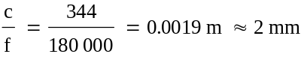.

Thus the minimum size of the object is about 2 mm.

6. A marine biologist uses an echo-sounder to find schools of fish. The echo-sounder uses ultra-sonic pulse. An echo-sounder sends a pulse to the sea bottom and it returns to the instrument 0.100 s later. If the speed of sound in water is 1456 m s-1, what is the water depth recorded by that echo-sounder?

s = v t = 1456 x 0.100 = 146 m
as the sound travels down and back, the depth is 73 m
7. Doctors use ultrasound with a frequency of several megahertz to form images of unborn babies. A transmitter sends short pulses of a narrow beam of ultrasound through the body of the mother. As the waves pass from one type of tissue to another they produce echoes. The diagram shows how the transmitter moves through a small angle between sending pulses.
a. If the transmitter sends out a pulse every 2 ms, how many pulses are sent out
in 0.200 s?
b. If the generator moves through an angle of 40.0° in 0.100 s, what is the angle between pulses?
c. If the swing by the generator is called a scan, how many scans does it produce each second?

a. 2 ms = 2 x 10-3 s
pulses = 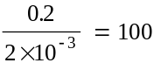

b. 0.100 s = 50 pulses (0.100 s is ½ of 0.200 s)
angle = 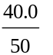= 0.80°

8. Some whales can communicate over hundred of kilometres using frequencies as low as 20 Hz. Why is a frequency of 20 Hz more effective than one of 2000 Hz?

The low frequency sounds travel more efficiently in water than high frequency sounds because they are better able than high frequency sounds to diffract around objects rather than bounce off them.

{A frequency of 20 Hz has a much longer wavelength than a frequency of 2000 Hz. Sounds having longer wavelengths are able to travel further than shorter wavelengths.}

9. The lookout on a ship is trained to scan the sea to note any differences in wave patterns. If a lookout notices an area of sea ahead where the waves are getting closer together what could this mean?

If the waves are closer together it means they are travelling more slowly. Water waves move more slowly in shallow water so it could be that the lookout has seen some shallow water.
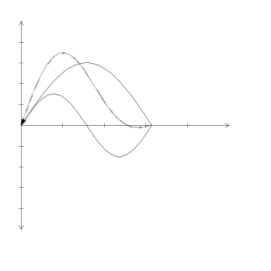
10. During a sound experiment you and your partner hold onto opposite ends of a rope. You each jerk the rope to send a pulse along the rope from each end, similar to the diagram. Draw a scale diagram to show what the resultant pulse looks like when the two pulses are exactly superimposed.

11. The diagram shows two superimposed waves. Use the superposition principle to draw a resultant displacement wave.

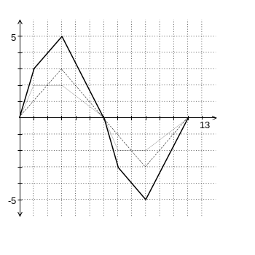

12. A child’s whistle has a distance of 12 cm between the opening and closed end, what is the lowest frequency note that the child can make on that whistle?

For a closed tube the longest wavelength (lowest frequency) is produced when there is an antinode at the opening and a node at the closed end.

i.e. 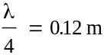 or λ = 0.48 m

as c = λ f (assuming the speed of sound is 340 m s-1)

f = 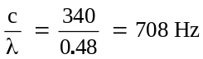

- A musical ensemble includes a violin, a guitar and a double bass.

- The violinist produces a fundamental note of frequency 512 Hz. If the string producing the note is 500 mm long, calculate the speed of the waves along the string.

string length = thus λ = 2 x 0.50 = 1.00 m

as c = λ f thus c = 1.00 x 512 = 512 m s-1

- The guitarist produces different notes by plucking a string with one hand while sliding a finger of the other hand down the string. describe what happens to the note the guitar produces when the finger slides down the string, and explain why the note changes.

As the finger moves down the string the note becomes more high pitched. The finger shortens the effective length of the string, this making the vibrations higher frequency

- The double bass has strings 1.25 m long. When the musician plucks one of the strings the speed of the waves in the string is 210 m s⁻¹. Determine the frequencies of the first three harmonic (fundamental and first two overtones) of this string.

the first three harmonics involve = 1.25 m λ = 2.50 m
λ = 1.25 m λ = 1.25 m
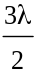 = 1.25 m λ = 0.833 m

as c = λ f

fundamental f = 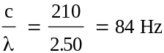

second harmonic f = 168 Hz

third harmonic f = 252 Hz

14. An organ repairer noticed that dust seemed to collect in certain regions inside organ pipes. She suspected that the way sound waves behaved inside the pipe determined the dust collection points. She drew standing wave diagrams to represent the first three harmonics in an organ pipe
a. open at both ends
b. open at one end only
Reproduce her two diagrams

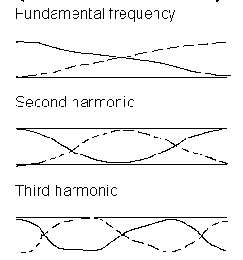
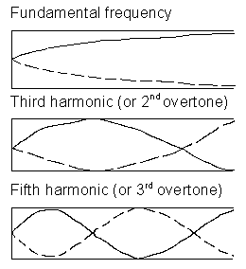

15. The table shows the musical notes C to C over one octave, and their ratios (of frequencies) compared with the first C. Complete the table by filling in the frequencies.

Note | c | d | e | f | g | a | b | c
Frequency | 256 | 288 | 320 | 341 | 384 | 427 | 480 | 512
Ratio

16. On the left is a table of frequency ranges for instruments and voices.
a. Which instrument has the greatest frequency range?
b. Which singer can produce the lowest pitched note?
c. Which instrument can produce the highest pitched note?
d. Which singer has the most restricted frequency range?

a. piano

b. bass

c. piano

d. bass or baritone (depending on the upper range)

17. During a performance two members of the school orchestra play the same pitch note on their different instruments. A student records the sounds and plays them back through a cathode ray oscilloscope, keeping all controls on the equipment constant. See the diagram.
Comment on the
a. loudness
b. frequency
c. wavelength

a. sound 1 is louder

b. sound 1 is lower in frequency

c. sound 2 has shorter wavelength

18. During a laboratory session a group of students measure the intensity of sound along a resonating air column. They used a tuning fork with a frequency of 512 Hz to set the air column resonating. They then plotted their results on a graph shown below.
a. Calculate the wavelength of the sound?
b. Hence, calculate the speed of sound in air?
c. If the air column is 1.12 m long, is it an open or closed pipe?

a. the spacing between nodes is half the wavelength.
as the spacing is 0.32 m, the wavelength is 0.64 m

b. as c = λ f

c = 0.64 x 512 = 328 m s-1

c. 1.12 m = 0.64 x
thus it must be a closed pipe as open pipes are some multiple of

{it is a closed pipe because there is a node at one end and an antinode at the other}

19. The diagram above shows the frequency ranges of several instruments compared with the notes on a piano.
a. Which instrument has the largest range of frequencies?
b. Which instrument has the most restricted range of frequencies?

a. violin 200 - 2500 Hz

b. double bass 40 - 250 Hz

The difference in terms of octaves covered (3 compared to 4) is less obvious.

20. A researcher produced cathode ray oscilloscope traces of the sounds made by different instruments. The diagram below shows five traces she produced. The controls of the cathode ray oscilloscope were unaltered during the experiment.
a. Which instrument produced the lowest pitched note?
b. Is the saxophone more likely to be a bass saxophone or an alto saxophone? Explain your answer.
c. Why do all the traces have a different shape?
d. Are the traces more likely to be of notes or noises? Explain your answer.

a. The trace shows the time taken for the vibratory motion to repeat. This is longest for the trumpet which therefore has the longest period and lowest frequency (pitch).

b. As the period for the saxophone is about the same as the flute, this suggests a higher pitched instrument - the alto saxophone.

c. Each instrument produces a different mixture of harmonics which add together to produce a different wave shape.

d. The regularity of the traces suggest that they are notes. A noise has no definite waveform.

21. When you set a tuning fork vibrating you can hear it better if you place the stem in contact with a solid such as a bench-top. Why is this so?

The vibrating tuning fork forces the benchtop to vibrate at the same frequency. The large surface of the bench vibrates more air molecules, making the sound louder. (The total energy available is unchanged so the tuning fork will cease vibrating more rapidly than if it is in the air.)

22. A singer was supposed to be able to smashed a wine glass simply by singing a certain note close to the glass. Explain the physical principle that could account for this.

If the note he sang was of the same frequency as the natural frequency of vibration of the air in the glass, then there will be resonance and the large amplitude vibrations that result will exceed the elastic limit of the glass and it will break.

23. Engineers who design tall chimneys, bridges, cables and masts build in devices that reduce resonance and limit the effect of forced vibrations. Why?

If there is resonance, then large amplitude vibrations will result and the movements may exceed the elastic limit of the material causing it break or fail.

24. A bat researcher gathered some data in the field and produced the graph on the right. The graph shows the frequency over time of single bat calls from three different species labelled A, B and C.
a. Which call would be from the Sheath-tail and Free-tail bats?

B

b. Which call would be from bats that use a large range of frequencies in their call?

A

c. Which type of bat produces the longest pulse call?

C

25. When driving an older type car you sometimes notice that at a certain speed a part of the car’s body vibrates excessively. Why does this happen?

At the given speed the engine is vibrating at a certain rate. If this happens to correspond to the natural frequency of the panel then it will resonate.

{This is due to forced vibration when the engine of the car forces other components to vibrate with the same frequency.}

26. When designing concert halls, acoustic engineers avoid ‘dead spots’ (places where you can hardly hear sounds from the stage that are audible in most other places in the hall).

- What could cause ‘dead spots’

They are caused by interference. Reflections from the walls or roof are causing destructive interference with the direct sound waves.

{Dead spots could be caused by the original sound being obstructed or being reflected so that it did not reach the area. The design of the building could be such that the sound is absorbed before it reached the area.}

- The diagrams show how two differently designed concert halls reflect sound. Which is the better design? Explain.

Concert Hall 2 is better. In Concert Hall 1, the audience seated where the arrows point would receive much of their sound reflected off the rear wall. This may cause interference effects and make the accurate location of the source of the sound on stage difficult.

{Concert Hall 2 is the better design because there is only a limited amount of reflection. Hall 1 will produce multiple sounds (reverberation).}

